**Take time to say #ThanksforCaring**

The amazing work of aged care workers will be recognised throughout Australia on Thursday 7 August, on Aged Care Employee Day (ACED).

These nurses, personal care workers, chefs, cleaners, gardeners, laundry staff, activity coordinators and administration staff play a key role in the lives of older people and their families, offering not only medical and physical care but also emotional support and companionship.

**[Facility or organisation]** is calling on **[local community name]** to recognise those who care for older Australians by saying “thanks for caring” for this national day.

“Every day, aged care employees perform their roles with immense dedication and compassion, often going above and beyond to ensure the well-being of our older community members,” **[Name]**, CEO of **[Organisation]** says.

“Aged Care Employee Day is an opportunity for all of us to express our deepest gratitude and appreciation for their invaluable contributions.

“We’re asking our community to take a moment and think about the quiet achievers and the superheroes who provide care with professionalism, compassion and dedication for our loved ones and give them the recognition they deserve,” **[CEO or spokesperson]** says.

ACED will feature a #ThanksforCaring social media campaign with videos, stories and photographs that acknowledge Australia’s aged care workers.

To mark ACED, **[Organisation]** will be hosting the following events and activities to celebrate and honour aged care workers:

**[Include details of any local events you are hosting]**

Now in its seventh year, ACED is a significant day on our national calendars, which acknowledges the thousands of people who care for and support millions of older people in Australia who receive aged care services.

Individuals, employers and community members wishing to take part in ACED can find information and resources on the Ageing Australia website: <https://ageingaustralia.asn.au/aged-care-employee-day>

ACED will also be the day when Ageing Australia announces the winners of the prestigious Ageing Australia 2025 You are ACE! Awards.

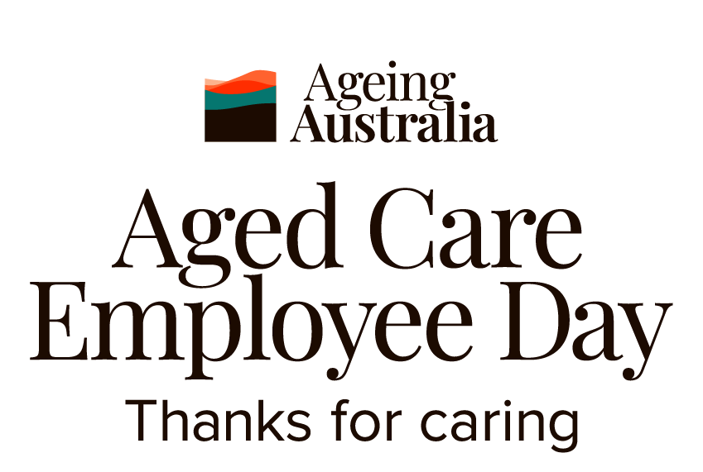

[Download the Aged Care Employee Day 2025 logo suite](http://ageingaustralia.asn.au/extlink/ACED2025/Ageing-Australia-ACED-logo-suite.zip) and [the toolkit](https://ageingaustralia.asn.au/sector-recognition-programs/aged-care-employee-day/aced-toolkit/)